**Assignment 10.1**

1. Create a job.properties file

nameNode=hdfs://localhost:9000

jobTracker=localhost:8032

oozie.libpath=${nameNode}/user/acadgild/workflows

oozie.wf.application.path=${nameNode}/user/acadgild/workflows

appPath=${nameNode}/user/acadgild/workflows

1. Create aworkflow.xml

<workflow-app name="DemoOozie" xmlns="uri:oozie:workflow:0.1">

<start to="demo-hive"/>

<action name="demo-hive">

<hive xmlns="uri:oozie:hive-action:0.2">

<job-tracker>${jobTracker}</job-tracker>

<name-node>${nameNode}</name-node>

<job-xml>hive-site.xml</job-xml>

<configuration>

<property>

<name>oozie.hive.defaults</name>

<value>hive-site.xml</value>

</property>

<property>

<name>hadoop.proxyuser.oozie.hosts</name>

<value>*</value>

</property>

<property>

<name>hadoop.proxyuser.oozie.groups</name>

<value>*</value>

</property>

</configuration>

<script>create_table.hql</script>

</hive>

<ok to="end"/>

<error to="end"/>

</action>

<end name="end"/>

</workflow-app>

1. Write a hive script

use default;

create table hive_oozie(

id INT,

name STRING)

ROW FORMAT DELIMITED FIELDS TERMINATED BY ',';

1. Then create a directory in hdfs

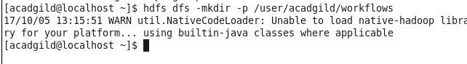

1. Put hive-site.xml,workflow.xml and hivescript file into hdfs in same directory

